**Major Research Project**

1. **Problem Statement**

Bruce County's beaches are popular destinations that attract a significant number of visitors each year. However, challenges such as water safety, beach overcrowding, and potential hazards impact the overall visitor experience. The Municipal Innovation Council has initiated a first-of-its-kind Smart Beach Project to address these challenges. The goal of this project is to implement innovative smart beach technology that enhances beach safety, provides real-time updates on water conditions and beach capacity, and improves visitor satisfaction.

1. **Objectives**

* **General Objectives**
  + Enhance beach safety for visitors
  + Improve the overall visitor experience at Bruce County's beaches
  + Support early hazard detection and timely response
  + Contribute to the effective management of beach capacity
* **Specific Objectives**
  + Implement smart beach technology that monitors water conditions, such as wave height, water temperature, and water currents
  + Utilize monitoring cameras to assess beach overcrowding and manage beach capacity effectively
  + Develop an accurate prediction model for rip currents to improve hazard awareness and prevention
  + Create an accessible, user-friendly platform that delivers real-time updates and alerts to beachgoers and relevant authorities

1. **Methodology**
2. Project planning:
3. System analysis:
4. System Design:

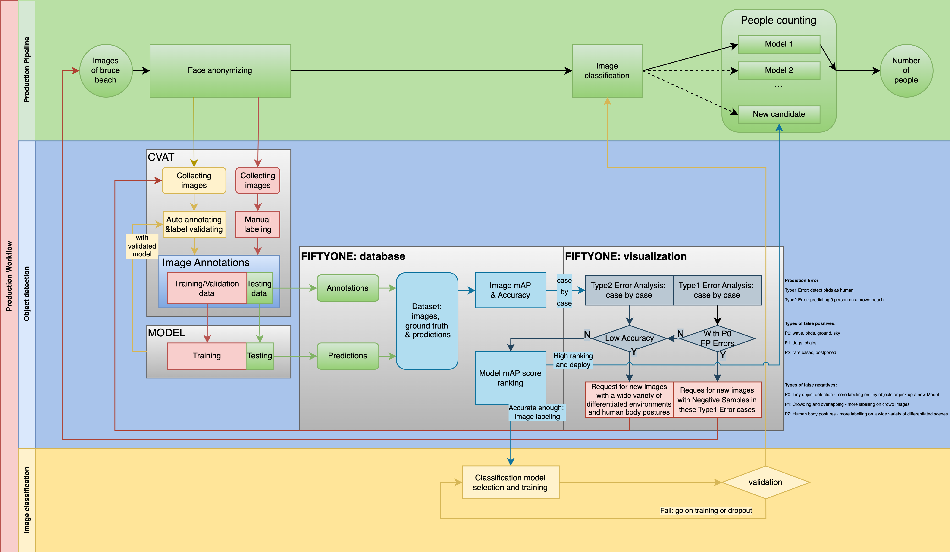

1. System Implementation
2. System Testing
3. Acceptance, installation and deployment
4. **Required Tools**
   1. **CVAT**

Project URL: <https://app.cvat.ai/projects/22547?page=1>

CVAT (Computer Vision Annotation Tool) is an open-source web-based application for the annotation of images and videos used for training computer vision algorithms. All images are split into 3 parts and labeled separately.

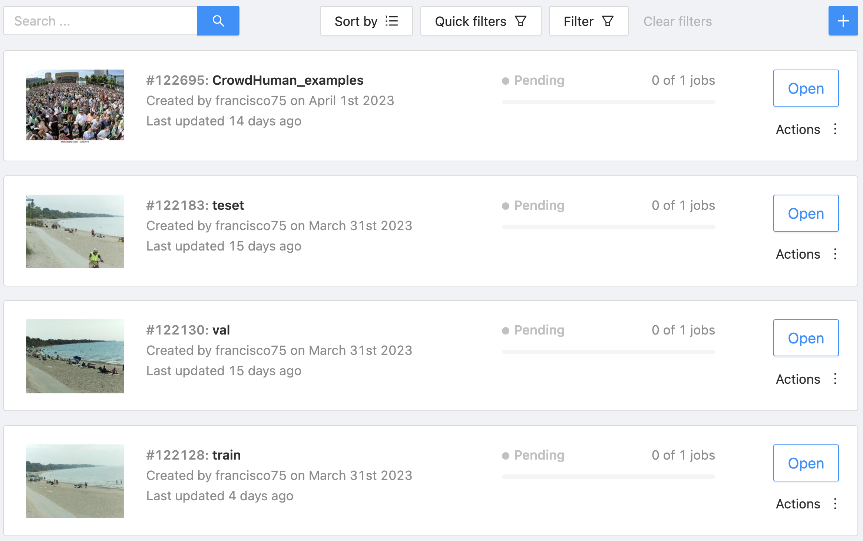

* 1. **FiftyONE**

FiftyONE is an open-source Python library for computer vision data management and visualization, providing consistent and scalable tools for image and video data processing and analysis. We manage all the testing results with annotations in the FiftyONE database.

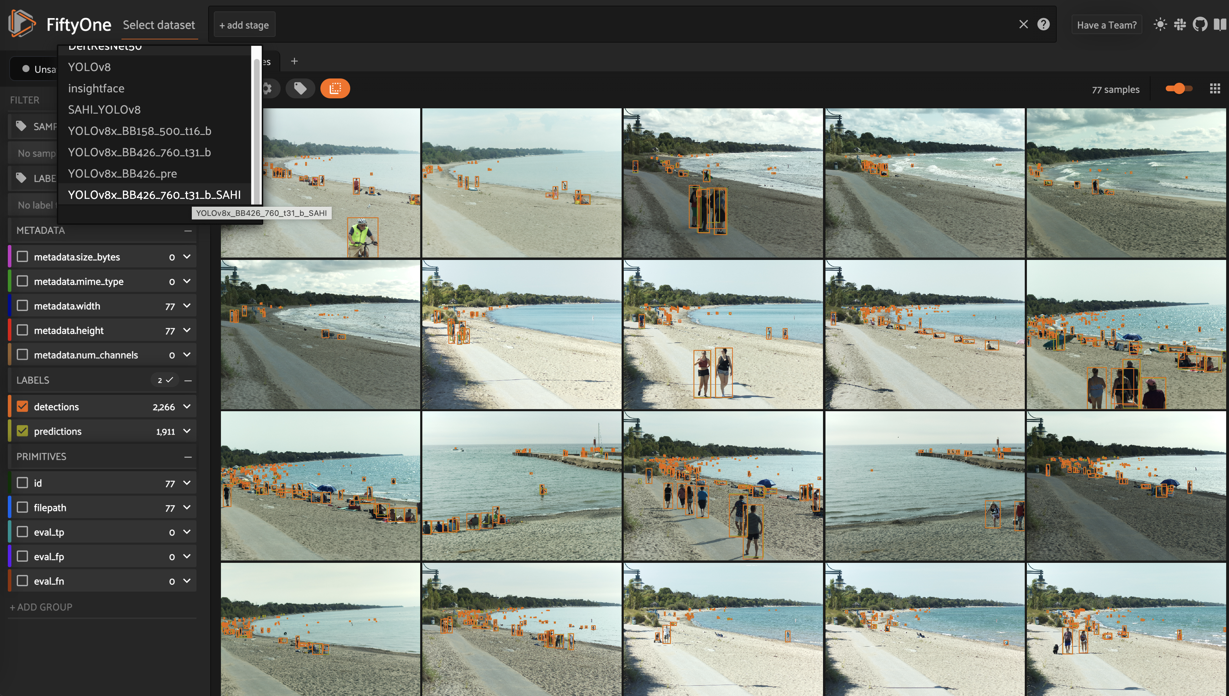

* 1. **Projects**

The projects are implemented in two parts:

Face anonymizing

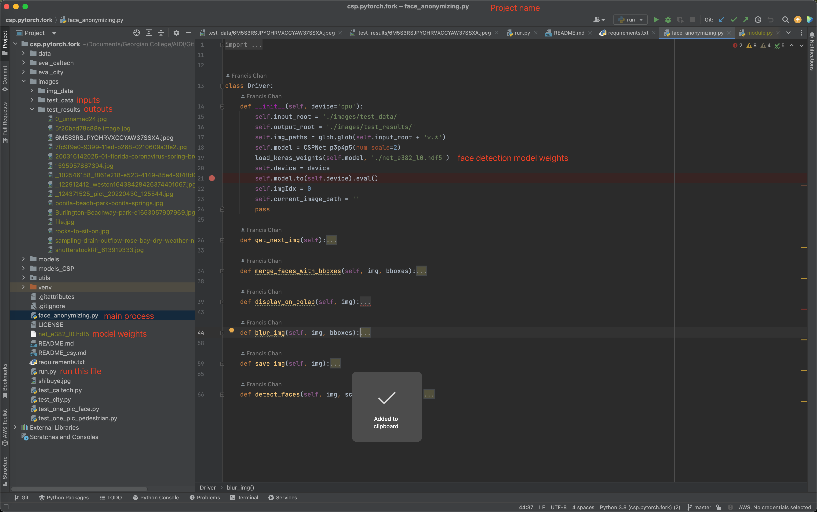

Object detection

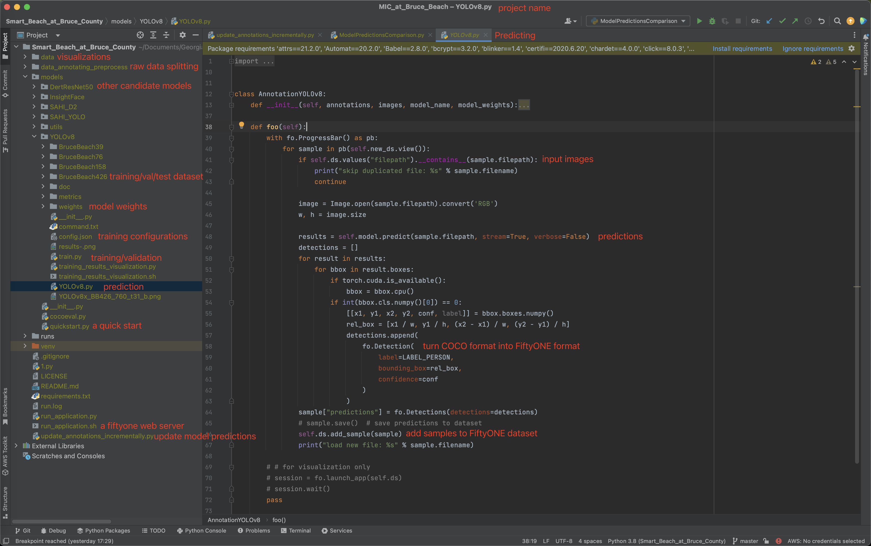

1. **Gantt Chart**

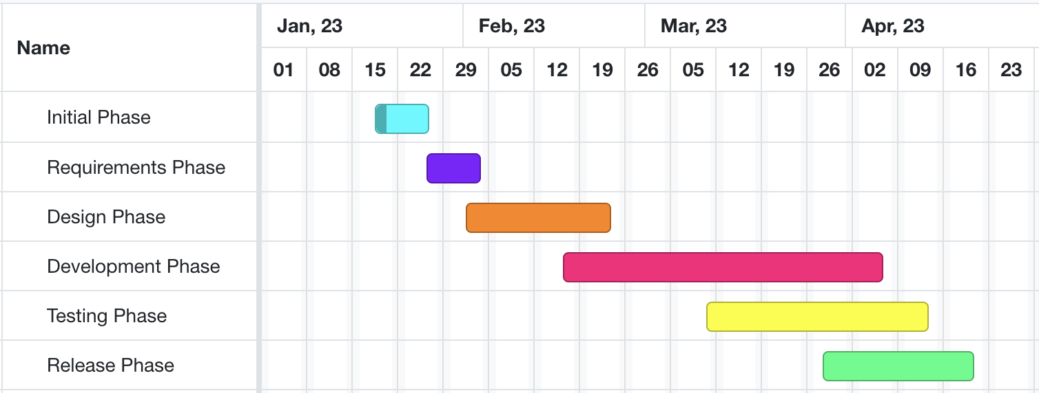

1. **Literature Review**

The literature review for the smart beach project will involve reviewing existing research and studies related to smart beach technologies, such as monitoring systems for wave, temperature, and water flow, as well as systems for crowd monitoring and offshore flow prediction. The review will also cover the use of artificial intelligence and machine learning algorithms in smart beach technologies, and their potential applications and benefits.

1. **Deliverables with Code**

The deliverables for the smart beach project will include two separate projects: face anonymizing and human counting. For the face anonymizing project, the deliverables will include the development and implementation of a functional prototype of the system, consisting of the software components required to automatically detect and anonymize human faces in images and videos. The code for the system will be made available to the project stakeholders, along with documentation and instructions for installation and use. In addition, the project will produce a report detailing the system design and implementation, as well as the testing and validation results.